**Lecture -7**

# Computer - Memory

A memory is just like a human brain. It is used to store data and instructions. Computer memory is the storage space in computer where data is to be processed and instructions required for processing are stored. The memory is divided into large number of small parts called cells. Each location or cell has a unique address which varies from zero to memory size minus one. For example if computer has 64k words, then this memory unit has 64 * 1024=65536 memory locations. The address of these locations varies from 0 to 65535.

Memory is primarily of three types

* Cache Memory
* Primary Memory/Main Memory
* Secondary Memory

## Cache Memory

Cache memory is a very high speed semiconductor memory which can speed up CPU. It acts as a buffer between the CPU and main memory. It is used to hold those parts of data and program which are most frequently used by CPU. The parts of data and programs are transferred from disk to cache memory by operating system, from where CPU can access them.

### Advantages

The advantages of cache memory are as follows:

* Cache memory is faster than main memory.
* It consumes less access time as compared to main memory.
* It stores the program that can be executed within a short period of time.
* It stores data for temporary use.

### Disadvantages

The disadvantages of cache memory are as follows:

* Cache memory has limited capacity.
* It is very expensive.

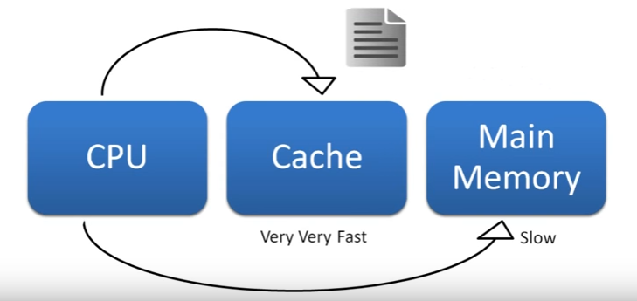

## Primary Memory (Main Memory)

Primary memory holds only those data and instructions on which computer is currently working. It has limited capacity and data is lost when power is switched off. It is generally made up of semiconductor device. These memories are not as fast as registers. The data and instruction required to be processed reside in main memory. It is divided into two subcategories RAM and ROM.

### Characteristics of Main Memory

* These are semiconductor memories
* It is known as main memory.
* Usually volatile memory.
* Data is lost in case power is switched off.
* It is working memory of the computer.
* Faster than secondary memories.
* A computer cannot run without primary memory.

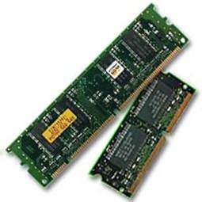

## Differences between RAM and ROM

RAM and ROM are both different types of memories used in any computer to make it fast and to enable it to access information stored in the computer. Every computer comes with a certain amount of physical memory which is actually chips that hold data. This memory is referred to as Random Access Memory or RAM. RAM is a part of hardware that stores operating system’s application programs and currently running processes that can be accessed randomly, i.e. in any order that the user desires. Data in RAM stays for only as long as the computer is running, and gets deleted as soon as computer is switched off. RAM usually comes in the form of microchips of different sizes such as 256MB, 512MB, 1GB, 2GB etc. Computers are so designed that this RAM can be increased up to a certain capacity.

ROM, on the other hand refers to Read Only Memory. Every computer comes fitted with this memory that holds instructions for starting up the computer. This is a memory that has data written permanently on it and is not reusable. However, there are certain kinds of read only memory that can be rewritten but they are called Erasable Programmable Read Only Memory, or EPROM. These are generally in the form of CD-ROM or Floppy Disk that can load the OS to the RAM.

Similarities between RAM and ROM end up with both being types of memories. There are glaring differences between the RAM and the ROM.

|  |
| --- |
| **Difference Between RAM and ROM**  • RAM is Random Access Memory, while ROM stands for Read Only Memory.  • RAM is volatile and is erased when the computer is switched off. ROM is non-volatile and generally cannot be written to.  • RAM is used for both read and write while ROM is used only for reading.  • RAM needs electricity to flow to retain information while ROM is permanent.  • RAM is analogous to a blackboard on which information can be written with a chalk and erased any number of times, while ROM is permanent and can only be read. One example is BIOS (basic input output system) that runs when computer is switched on and it prepares disk drives and processor to load OS from disk. |

## Secondary Memory

This type of memory is also known as external memory or non-volatile. It is slower than main memory. These are used for storing data/Information permanently. CPU directly does not access these memories instead they are accessed via input-output routines. Contents of secondary memories are first transferred to main memory, and then CPU can access it. For example: disk, CD-ROM, DVD etc.

### Characteristic of Secondary Memory

* These are magnetic and optical memories
* It is known as backup memory.
* It is non-volatile memory.
* Data is permanently stored even if power is switched off.
* It is used for storage of data in a computer.
* Computer may run without secondary memory.
* Slower than primary memories.

